

**To: City Executive Board**

**Date: 17 December 2015**

**Report of: Head of Financial Services**

**Title of Report: Treasury Management Performance Report for the six months ending 30 September 2015**

# Summary and Recommendations

**Purpose of report**: To report on the performance of the treasury management function for the 6 months to 30 September 2015.

# Key decision No

**Executive lead member: Councillor Ed Turner**

**Policy Framework: Efficient and effective Council**

**Recommendation(s):** That the City Executive Board resolves to

1. note the performance of the treasury management function for the six months to 30 September 2015

**Appendix 1 – List of investments as at 30th September 2015**

**Appendix 2 – Risk Register**

**Reason for Report**

1. In its Code of Practice on Treasury Management, the Chartered Institute of Public Finance and Accountancy (CIPFA) requires that the Council receives an updated report on Treasury Management activities at least twice a year; this report provides members with an overview of Treasury Management performance for the first half of the 2015/16 financial year.

**Economic Overview**

1. The UK economy slowed a little in early 2015 but domestic demand has been helped by lower oil prices. Growth in UK GDP is expected to average around 2.5% in 2015, driven mainly by consumer spending and business investment. There are risks to this growth including uncertainties relating to Greece and the recent turbulence in the Chinese stock market. There is also concern about lower Chinese growth than expected which could have an effect on the global economy and especially on those countries undertaking significant levels of trade with China.
2. Although the Consumer Prices Index fell by 0.1% in the year to September 2015, it is expected to gradually rise towards its 2% target by the end of 2016, but remaining below 1% until the spring of 2016. Until inflation begins to rise there is little prospect of a rise in interest rates. Interest rate rises are not expected until 2016 and even then they are only likely to rise gradually. This therefore has an adverse effect on the ability of the Council to raise income through investments in the short term to medium term. Average interest rates received by the Council for 2015/16 are expected to be lower than originally expected when setting the budget, putting pressure on the investment income budget. Interest expectations incorporated into the budget going forward have been reduced in line with market expectations of slow interest rises.

**Investment Performance 2015/16**

1. The cumulative average rate of return on investments to 30th September 2015 was 1.23%, which is 0.23% above the performance target of 1%. The primary reason for the Council’s return being above target is due to its investment in property funds and it is important to note that without these, the return would fall below target due to longer term investments reaching maturity and being reinvested at a lower rate and (in some cases) for shorter durations due to a rather static market and limitations imposed on the approved lending list.
2. The budgeted investment income for 2015/16 is £0.942 million. As at the 30th September 2015, forecast investment income has been calculated at £0.806m (an underachievement of £0.136 million). Income to date is £0.385m. This underachievement is due to interest rates being lower than market analysts were predicting at the time that the budget was set. This has an ongoing impact into 2016/17 and the interest rate assumptions will be adjusted as part of the budget refresh process.
3. To date £10-20m has been held in money market funds, averaging an annual interest rate of 0.4%. In light of interest rate projections the amount held in these funds going forward will be reduced to £5-10m, enabling more cash to be invested into fixed-term deposits. The majority of which will be arranged for a 6-month period at an average rate of 0.6%. This should result in increased investment income in the second half of the financial year.
4. The Council’s investment balances have gradually increased as the financial year has progressed. Average cash balances in April 2015 were £55.6m and this figure has steadily risen month on month. As at 30th September 2015, the Council’s total investments amounted to £71.4m. This is the expected, usual position for the time of year as traditionally, income exceeds expenditure (due to grant receipts, business income etc) but investment balances are expected to decrease towards the end of the financial year when less income is collected.
5. The Council has a range of investment types (i.e. fixed deposits, certificates of deposit, externally managed property funds, call accounts and money market funds) which are deposited across different counterparties including banks, building societies and Local Authorities. The chart below shows the distribution of the Council’s Investment Portfolio as at 30th September 2015; the bars show the value of investments and the line shows the percentage of the portfolio invested in that counterparty:

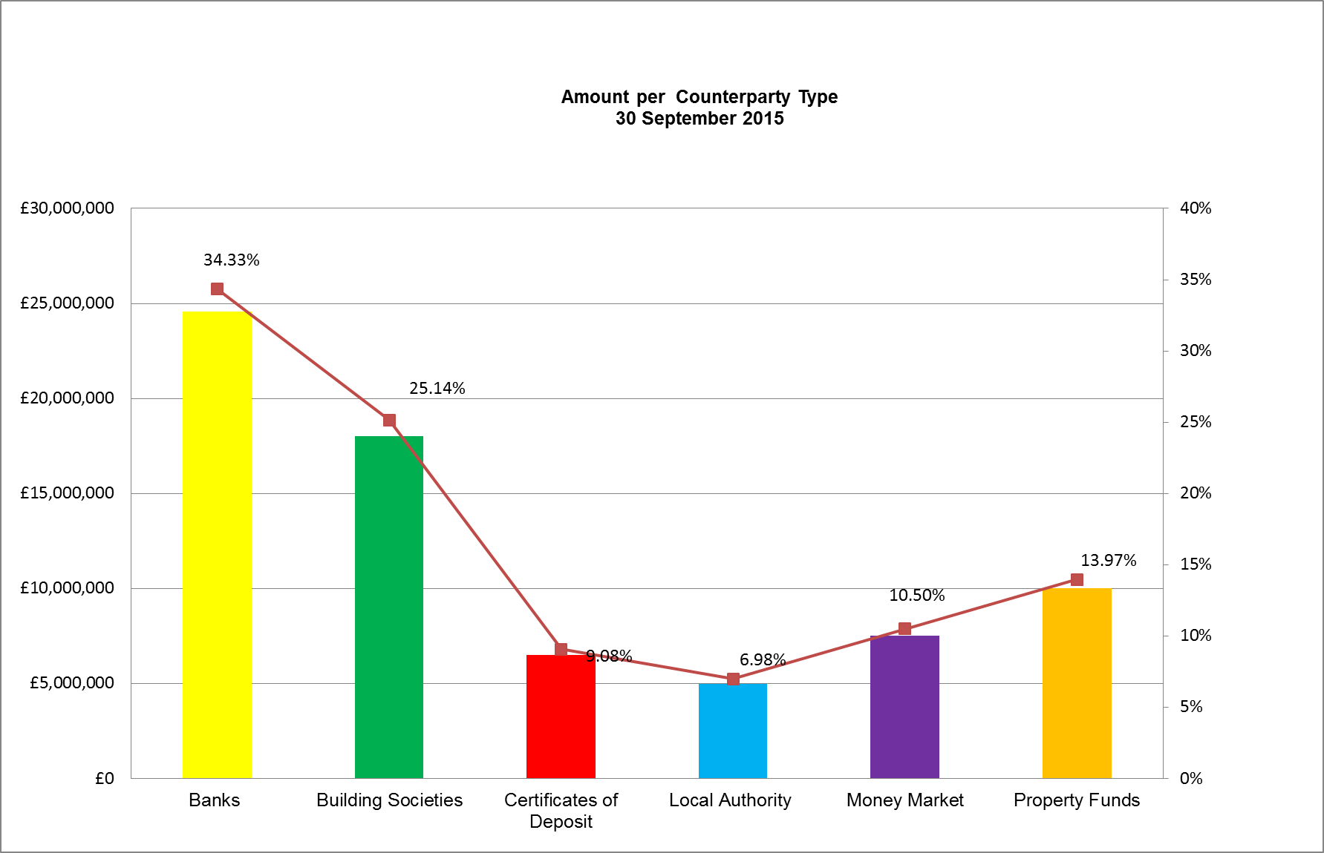

1. The graph below compares the Council’s in-house average rate of return for each month to the Bank of England’s Base Rate and the benchmark interest rates:

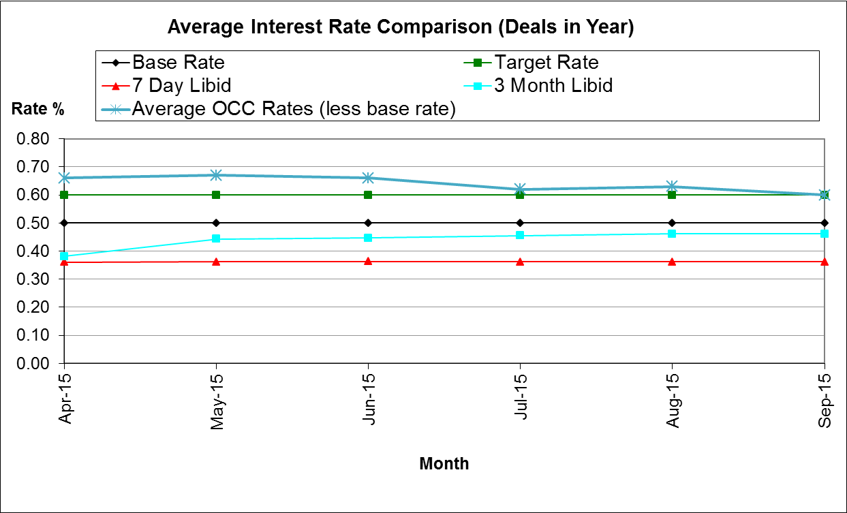

1. The graph shows that the Council has consistently performed above target for the first half of the financial year and it is believed that the rate of return will continue to be above target for the remainder of the year. Base Rate remains at 0.50% and current forecasts indicate that it will remain at this rate into 2016.

**Icelandic Investments**

1. In October 2008, the Icelandic banks Landsbanki, Kaupthing and Glitnir collapsed and the UK subsidiaries of the banks, Heritable and Kaupthing Singer and Friedlander went into administration. The authority had £4.5 million deposited across 2 of these institutions, with varying maturity dates and interest rates
2. Original balances were £3m with Heritable (which formed part of the Landsbanki group) and £1.5m with Glitnir. Heritable has repaid £2.94m plus interest to date, with the most recent repayment being received on 9th September 2015. The outstanding balance is £0.88m.
3. At the beginning of the financial year, £0.2m of the Council’s initial (£1.5 million) deposit with Glitnir was outstanding and being held in Iceland, under Icelandic law. Following negotiations with the public services law firm, Bevan Brittan and the Local Government Association, the Council sold its remaining Glitnir impairment in August 2015 and received £116k from Deutsche Bank on 24th September 2015. The final payment received does not directly correlate with the outstanding balance due to exchange rate losses but as far as the Council is concerned, funds have now been fully recovered.

**Property Funds**

**CCLA Investment Management Limited**

1. CCLA is a specialist investment management firm that acts on behalf of charities, faith organisations, and local authorities. The amount invested in the CCLA property fund was £3m (September 2013). The investment has produced quarterly returns ranging between 4% and 6% to date and it is expected that the fund will continue to achieve rates in this region. The impact of this return is illustrated in the average weighted monthly return shown in the interest graph at paragraph 9 above.
2. In addition to the interest earned from the CCLA property fund, the value of the Council’s investment has appreciated from £3m since inception to £3.7m as at 30th September 2015. Since the beginning of the current financial year, the annualised capital growth of the fund for the year stands at 14.32% excluding dividends and 17.57% inclusive of dividends. However, it is important to note that property values can decrease as well as increase and to be mindful of the risks involved with this type of investment.
3. The table below shows the gains and losses made on the fund each quarter this year (Plus the figures at 31st March 2015 in order to show the opening position) and also details the quarterly dividends received. The Council holds 1,273,612 units in the fund and the unit price is re-valued on a monthly basis, reflecting the current value of the investment (but not the interest).



**Lothbury Property Fund**

1. During 2014/15, the Council invested £7m into the Lothbury Property fund and the fund has produced quarterly returns in the range of 3-4% to date.
2. The table below shows the gains and losses made on the fund each quarter this year (Plus the figures at 31st March 2015 in order to show the opening position) and also details the quarterly dividends received. The Council holds 4,219 units in the fund and the unit price is re-valued on a monthly basis, reflecting the current value of the investment (but not the interest).



1. In addition to the interest earned from the Lothbury property fund, the actual principal value of the Council’s investment has increased from £7m since inception to £7.6m as at 30th September 2015. Since the beginning of the current financial year, the annualised capital growth of the fund for the year stands at 14.12% excluding dividends and 17.64% inclusive of dividends.
2. As with CCLA, the overall positive impact of returns from the Lothbury investment is illustrated in the average weighted monthly return graph under paragraph 9.

**The Treasury Management Counterparty List**

1. The approved counterparty list provides limits to the maximum amount which may be invested per counterparty/counterparty group at any given point and it also confirms the maximum duration permitted per investment. The Council adheres to this listing to ensure it does not breach its Treasury Management Strategy. The list is updated on a weekly basis, sometimes more frequently if changes in the market dictate a more imminent review.

1. The Council’s approved counterparty list is based upon recommendations from Capita Asset Services although ultimate authorisation of which counterparties are approved rests with the Council’s S151 Officer. In essence, the approved counterparties are determined by credit ratings provided by the three main credit rating agencies and through the monitoring of counterparties’ credit default swap spreads.

**Borrowing**

1. The Council has not taken on any additional debt during the year to date and so the balance of its external borrowing remains at approximately £198.5 million as at 30th September 2015; this figure relates to funds borrowed from the Public Work Loans Board (PWLB) to buy out the Housing Revenue Account (HRA) from the subsidy system and relates wholly to Housing with interest repayment being met by the Housing Revenue Account. The Council does not consider that debt restructure and/or premature repayment would be practical at this time as the Council would incur a large premium from the PWLB for doing so and it is actually more economical to continue paying interest on the existing debts.
2. The Council continues to monitor borrowing interest rates and forecasts on a regular basis and as such, would review its position on debt restructuring if this were to become a more favourable option in the future.

**Climate Change / Environmental Impact**

1. There are no issues arising directly from this report

**Equalities impact**

1. There are no equalities impacts arising directly from this report

**Financial Implications**

1. Financial implications are contained within the body of the report.

**Legal Implications**

1. There are no legal implications directly relevant to this report.

**Risk Implications**

1. There are no risks in connection with the report’s recommendations. Risk assessment and management is a key part of Treasury Management activity especially in the selection of counterparties when considering investment opportunities. The Council uses external advisors and counterparty credit ratings issued by the rating agencies to assist in this process.

|  |
| --- |
| **Name and contact details of author:-** |
| Name: Angela Turner |
| Job title Technical Officer (Treasury Management & VAT) |
| Service Area / Department Financial Services |
| Tel: 01865 252739 e-mail: [aturner2@oxford.gov.uk](mailto:aturner2@oxford.gov.uk) |

**List of background papers: None**